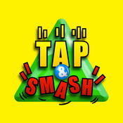
Jump into unlimited gameplay with Tap and Smash!
Randomly generated levels means each time you play is completely different!
Strategically tap to maneuver your way through impossible levels!
Smash your way through obstacles with incredible strikes, blasts, nukes, and freezes!
You’ll absolutely love the HD graphics and amazing sounds.
Can you dominate the global leaderboards?
Get Tap and Smash today and find out!

